EE463 Hardware Project

Final Report

15 January 2020



Team “Blue Smoke”

Paul Brown – 2463461

İbrahim Duru – 2166304

Mustafa Şahin

Table of Contents

Formula Sheet 3

Introduction 4

Simulations 4

Voltage Source Model 4

Motor Calculations and Modeling 4

Three-Phase Thryristor Rectifier Simulation 10

Three-Phase Diode Rectifier + Buck Converter Simulation 12

TRIAC AC Chopper + Diode Bridge Rectifier 14

Topology Comparison and Selection 20

Three-Phase Thyristor Rectifier 20

Rectifier + Buck Converter 20

Single-Phase Thyristor Rectifier 20

Chosen Topology: Single-Phase Diac-Controlled Triac rectifer 20

Component Selection 22

Triac Selection 22

Diac Selection 22

Capacitor Selection 23

Resistor Selection 23

Additional Components 23

Conclusions 23

# Formula Sheet

1. Vt = Ea + Ia x Ra (1)
2. Ea = Laf x If x wm  (2)
3. T = Laf x If x Ia (3)  
   Ea = Vt - Ia x Ra (4)
4. Ea x $\frac{I_{a}}{ω_{m}}$ = $T$ (5)
5. T = P/ωm (6)

# Introduction

This report presents designing a rectifier circuit that will be used to drive a DC motor. The circuit implemented for the project was a diac-controlled triac circuit. This circuit essentially utilizes an RC circuit with a diac to control the firing angle of the triac. The triac operates on both the positive and negative half-cycles of the input AC voltage supply to chop the voltage down. The chopped AC voltage is then rectified through a full-wave diode bridge rectifier to become a controlled DC output to drive the DC motor.

The design process began with simulations of various candidate topologies. The candidate topologies, simulation results, discussion of the topology selection, and preliminary component selection can be found in the team’s Simulation Report (submitted 4 December 2019).

This report describes the simulations of the selected diac-controlled triac circuit topology with modifications relative to the previous submission since component models were updated based on the selected components. The report goes on to present the thermal design calculations for the project, the procurement and assembly process, and project testing and demonstration. Throughout this report, lessons learned through the experiences of the project team are summarized.

# Simulations

Simulations were performed for various topologies under consideration to better understand the advantages and disadvantages among them and to show some of the component ratings that would be needed for those topologies to be applied. The topologies simulated were a three-phase thyristor rectifier, a three-phase diode rectifier with buck converter, and a TRIAC-based AC chopper to diode bridge rectifier. After presenting some common calculations, the simulations results for the selected TRIAC-based AC chopper circuit will be shown. Results for the other topologies that were not selected can be found in the projects’ simulation report. Since some modeled component values were changed based on parameters from the datasheets of the selected components, the results presented here are different from those in the previously submitted simulation report.

## Voltage Source Model

The converter designed in this project will be fed from a variable transformer (variac) adjusted to give the desired output voltage. It is assumed that the variac output voltage will be adjusted to a desired setpoint prior to connecting load to the output of our converter. For the three-phase rectifier and buck converter models, a variac output voltage of 120 Vrms,l-n was selected. This voltage level allows the converters to be in the middle of their regulating range while providing 175 VDC output.

For the triac-based model, since it is fed from single-phase voltage source and because the diac circuit needs a substantial voltage headroom over the motor back EMF in order to charge, the variac is simulated as set to 220 Vrms,l-n. Based on simulations, this voltage allows the circuit to achieve 175 VDC (average) output to the motor.

The source impedance of the lab AC power supply and variac is not known, but for modeling purposes, it was represented with a resistance of 50 mΩ and an inductance of 180 μH. This works out to an available short-circuit current at 120 V of 1590 A.

## Motor Calculations and Modeling

In this project, the DC motor load to be driven by the electronic power converter should be represented in the simulations. In Simulink, it is possible to represent the DC motor load as a motor with a torque load or using the Ea, Ra, La equivalent circuit elements. Both representations were developed for our Simulink model, but for the simulation results, the Ea, Ra, La equivalent circuit elements were used.

The parameters for the DC motor model were calculated based on the nameplate data of the motor and parameters provided with the project assignment.

The nameplate is shown in Figure 1 below.

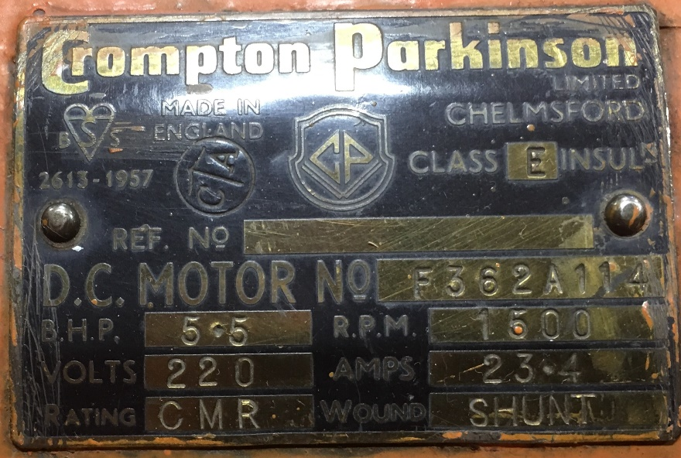

Figure 1: DC Motor Nameplate

Additional motor parameters were provided with the project assignment. The motor data taken from this information is summarized in Table 1.

Table 1: DC Motor Provided Parameters

| Parameter | Value |
| --- | --- |
| Pmec | 5.5 HP |
| RPM | 1500 |
| VS | 220 V |
| IS | 23.4 A |
| Armature Winding | 0.8 Ω, 12.5 mH |
| Shunt Winding | 210 Ω, 23 H |
| Interpoles Winding | 0.27 Ω, 12 mH |

The DC motor model in Simulink takes some additional parameters that were not provided, but which can be calculated from the available information.

Rated speed (rad/s) = $\frac{1500x2xπ}{60}$ = 157 rad/s

Rated field current (A) = $\frac{220V}{208Ω}$ = 1.06 A

Simulink also takes parameters for armature-field mutual inductance Laf as well as a friction coefficient. These can be calculated from the provided values for motor operation at rated speed, power, voltage, and current, as is shown in the following subsection.

### Motor Operation at Rated Load

The equivalent circuit parameters for a DC motor are the following:

Vt = Ea + Ia x Ra (1)   
Ea = Laf x If x wm (2)   
T = Laf x If x Ia (3)

(In many formulations, Ka*Φ is used instead of Laf*If, but since Simulink will use Laf, it is convenient that we use this formulation.)

Prated = (5.5 HP) x (746 $\frac{W}{HP}$) = 4103 W. This power is mechanical output.

At rated speed of 157 rad/s, rated mechanical torque is   
(4103 W)/(157 rad/s) = 26.12 N-m.

Since the motor is rated for a shunt configuration,  
If = = 1.05 A

Rated electrical input is (220 V) x (23.4 A) = 5148 W (neglecting any reactive power). So rated efficiency is approximately 0.80.

Resistive losses in armature = (22.4 A)2 x (0.8 Ω) = 401 W. Remaining losses are in the field resistance and friction.

At full load Vt = 220 V and Ea = Vt - Ia x Ra = 220 V - (0.8 Ω)*(22.4 A) = 202 V. (4)

Laf = = = 1.23 H

Laf*If = 1.05 A * 1.23 H = 1.29

The electrical torque can be calculated as  
Ea x $\frac{I_{a}}{ω_{m}}$ = $\frac{\left(202V\right)x\left(22.4A\right)}{157}$ = 28.76 N-m. (5)

Since the rated output mechanical torque is 26.1 N-m, apparently there are additional mechanical torque losses. The simplest is to model them as Coulomb friction losses (i.e. constant torque):  
Te - T = 28.76 N-m - 26.12 N-m = 2.64 N-m

At rated speed, this works out to friction loss of  
2.64 N-m * 157 rad/s = 415 W.

### Simulink Parameters

When modeled as a DC motor in Simulink, the parameters entered are as shown in Figure 2.

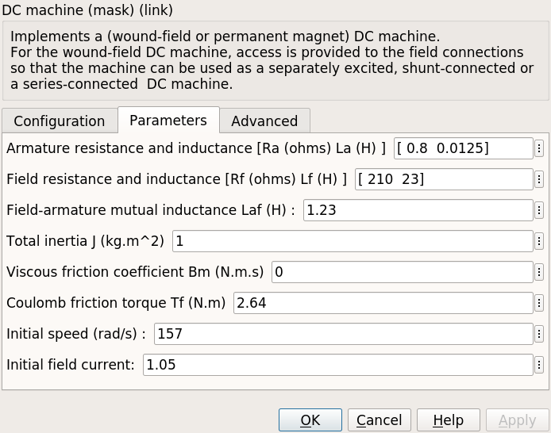

Figure 2: DC Motor Simulink Parameters

When modeled using Ea, Ra, and La, Ra and La are entered directly as shown in the datasheet, but back EMF Ea should be calculated based on the operating speed. Ea was calculated for rated load above, and is calculated for other load conditions in the following subsections, the results of which are summarized in Table 1. A terminal voltage of 175 V is chosen since the problem specifies that Vmax < 180 V, but lower voltages require higher current to get the same power output.

Table 2: Equivalent Ea for Various Load Conditions

| Load Condition | Vt (V) | Ea (V) | ωm (rad/s) | External  T (N-m) |
| --- | --- | --- | --- | --- |
| Starting | 175 | 0 | 0 | 283 |
| No Load | 175 | 171 | 133 | 2.6 |
| Kettle Load (1600 W) | 175 | 164 | 127 | 15.4 |
| Rated Load | 220 | 202 | 157 | 26.1 |

### Startup

At startup, ωm = 0, so Ea = 0.

Torque and current at startup will depend on how much voltage is applied. If full rated voltage were applied, startup current would be  
Ia = = 219 A  
T = 219 * 1.29 = 283 N-m

This is too much current and torque, so the applied voltage must be reduced for starting the motor.

### No Load

The motor running at no load has only to output mechanical power equal to the friction of the running motor and coupled AC synchronous machine.

Neglecting voltage drop on the armature winding such that Ea = Vt, speed can be estimated as $\frac{E_{a}}{L_{af}⋅ω_{m}}$ 
= $\frac{175}{1.29}$ = 136 rad/s

Based on the coefficient of friction calculated in the full load section above, the mechanical power at this speed can be estimated as  
2.65 N-m x 136 rad/s = 360 W

Estimating additionally that the connected synchronous maching has a similar amount of friction, the total "no load" load is estimated as 700 W.

At no-load, this friction loss will have the following circuit values:

Vt = 175 V  
Ia x Ea = 700 W ⇒ Ea =

= 175 V - Ia x (0.8 Ω)

700 W = (175 V) x Ia - Ia2 x (0.8 Ω)

0 = 0.8 x Ia2 – 175 x Ia + 700

Ia = = 4.1 A.

Ea = = 171 V

No-load speed can be calculated as

ωm = = = 133 rad/s.

This is 133/157 = 85% of rated speed.

The external torque to account for the synchronous generator friction is estimated as  
350 W / 133 rad/s = 2.6 N-m

### Kettle Load

For the “Robust Design” bonus, the motor must be run such that it supplies power to a 1600-W water kettle connected to the output of the synchronous machine coupled to the DC motor. Based on the additional friction load calculated for “no-load” operation, the total mechanical power for the kettle load is 2300 W.

The kettle load is calculated to have the following circuit values:

Vt = 175 V  
Ia x Ea = 2300 W ⇒ Ea =

= 175 V - Ia x (0.8 Ω)

2300 W = (175 V) x Ia – Ia2 x (0.8 Ω)

0 = 0.8 x Ia2 - 175 x Ia + 2300

Ia = = 14.0 A.

Ea = = 164 V

Speed can be calculated as

ωm = = = 127 rad/s.

This is $\frac{127}{157}$ = 81% of rated speed.

At ωm = 127 rad/s, the estimated 1950 W external mechanical load will have a torque of  
T = P/ωm = = 15.4 N-m. (6)

## TRIAC AC Chopper + Diode Bridge Rectifier

The last topology that was considered is a simple triac AC chopper circuit connected to the DC motor through a diode bridge. This topology was not presented in class, but when asked about how to generate the gate signals for a thyristor rectifier, he suggested that we could use triac and diac components and recommended basic driver circuits. After some research on possible thyristor driver circuits, we found a circuit in the Littlefuse “Phase Control Using Thyristors” Application Note AN1003 that we thought could possibly work for this project. A schematic of the circuit we designed is shown in Figure 3.

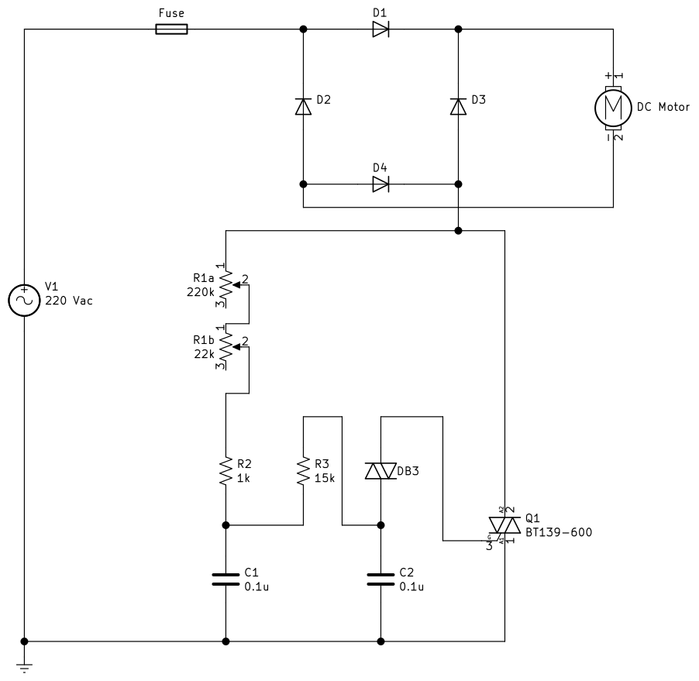

Figure 3: TRIAC DC Motor Control Circuit

Simulating this circuit is complicated in Simulink by the fact that Simulink does not have any triac or diac models in the toolbox. In order to implement the circuit in Simulink, a triac model was developed by placing two thyristors in parallel but with opposite polarity and connecting the firing signals together. Based on the selected BTA26 triac, the forward voltage was modeled as 1.3 V based on the datasheet maximum forward voltage drop for the triac. The triac was modeled with a resistance of 16 mΩ based on the dynamic resistance stated on the datasheet. The input resistance of the triac gate was modeled with a resistance of 1 kΩ since that gives a gate current pulse of 10-20 mA when the diac fires and seems to be in the right order of magnitude.

A Simulink diac model was created by making the same counter-parallel connection as was done for the triac and then creating logic in the firing circuit such that the diac fires when the voltage across the device exceeds its characteristic turn-on voltage. A diac breakover voltage Vbo of 32 V was used based on the selected DB3 diac. The DB3 has a minimum dynamic breakover voltage ΔV of 5V, so the diac was modeled with a forward voltage of 27 V.

Figure 4 shows the full triac-based Simulink model.

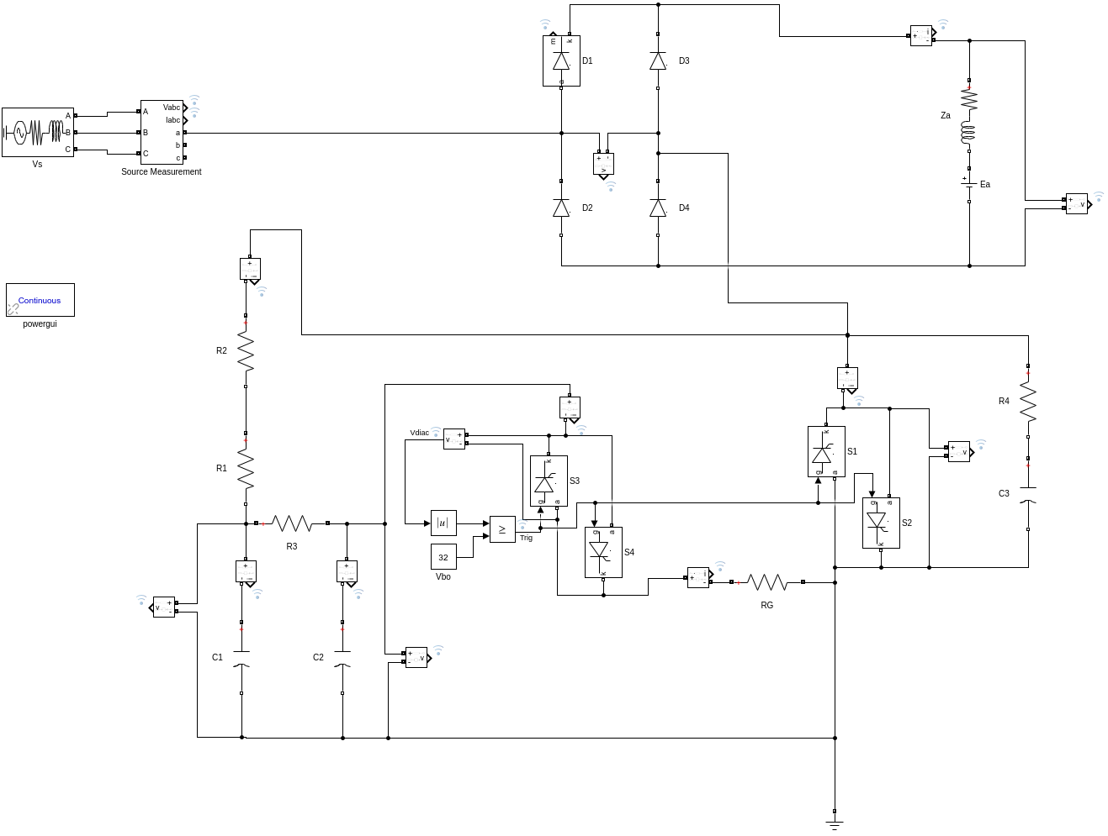

Figure 4: Triac-Diac Simulink Model

### Small Resistive Load

In order to test that the circuit works as expected and see the range of control of the triac, the model was first tested using relatively small resistive load of 100 Ω on the rectifier output. The resistance of R1, representing the control potentiometer, was varied and the output voltage and current waveforms recorded. Results of these simulations are shown in Figure 5.

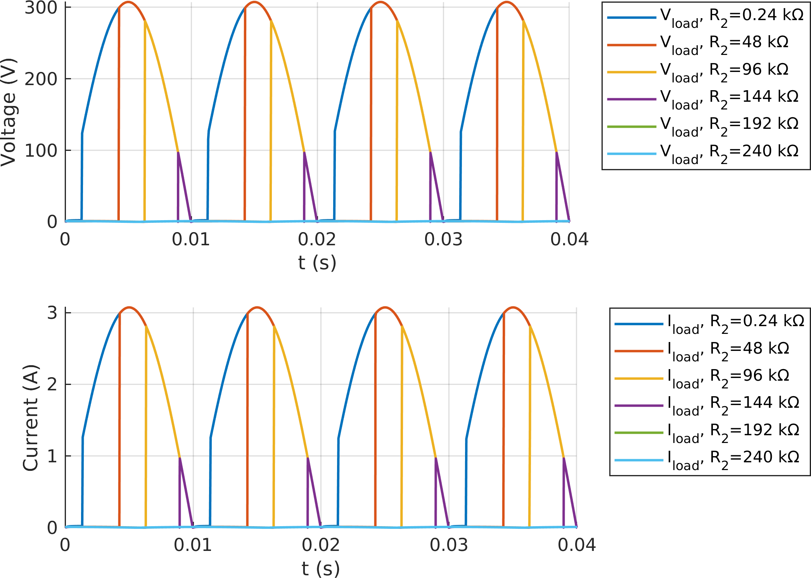

Figure 5: Triac-Diac Simulink Results with Small Resistive Load

As can be seen from Figure 5, the diac firing circuit is limited in its ability to fire at angles near 0° and near 90°. From what we have read about diac-triac circuits, this “snapping on” behavior is typical of this type of circuit, and we observed it during testing as well.

### DC Motor Load

Once the circuit was simulated using the small resistive load and was giving reasonable results, we passed to simulations using the equivalent circuit for the DC motor as we did for the other topologies. For each load condition, the R1 resistance was adjusted to give an average output voltage appropriate to the load condition. For the motor start, this was set to obtain current near or less than the rated current of the motor. For no load and kettle load conditions, the output voltage was adjusted to 175 V. In this case, the rated motor load was not simulated since a phase-to-neutral supply voltage of 220 V was not sufficient to obtain an output voltage of 220 VDC. Since the problem statement restricts the output voltage to less than 180 VDC anyway, the rated load simulation is not essential to the project.

Figure 6 shows the output voltage and current waveforms for the simulations of the triac-based control model.

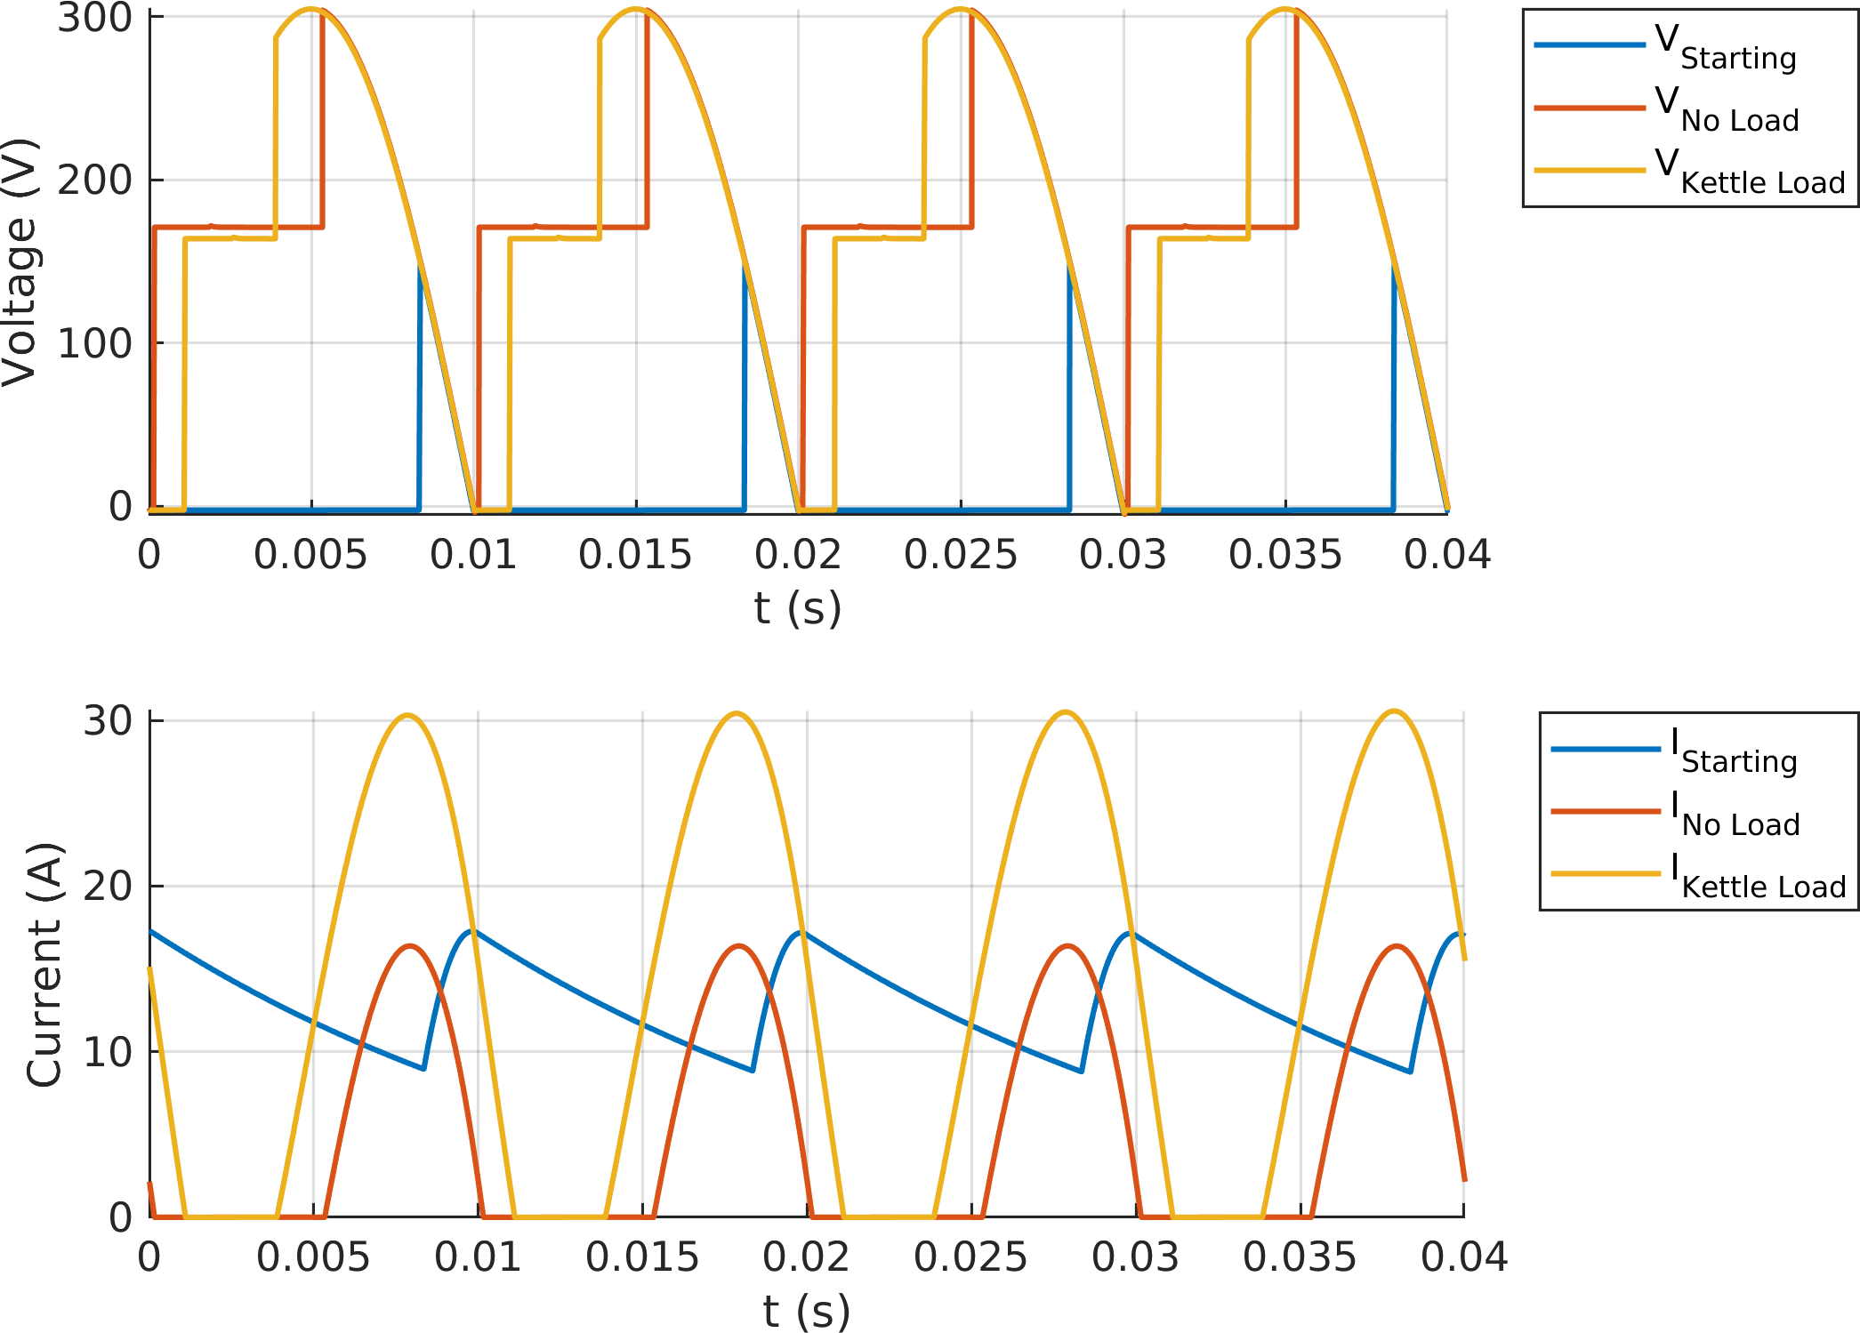

Figure 6: Triac-Diac Simulation Output Waveforms

In Figure 6, we can see that the output current is continuous only for the starting case. In the other two load cases, current was discontinuous. This is largely due to the use of a single-phase AC voltage source rather than three-phase.

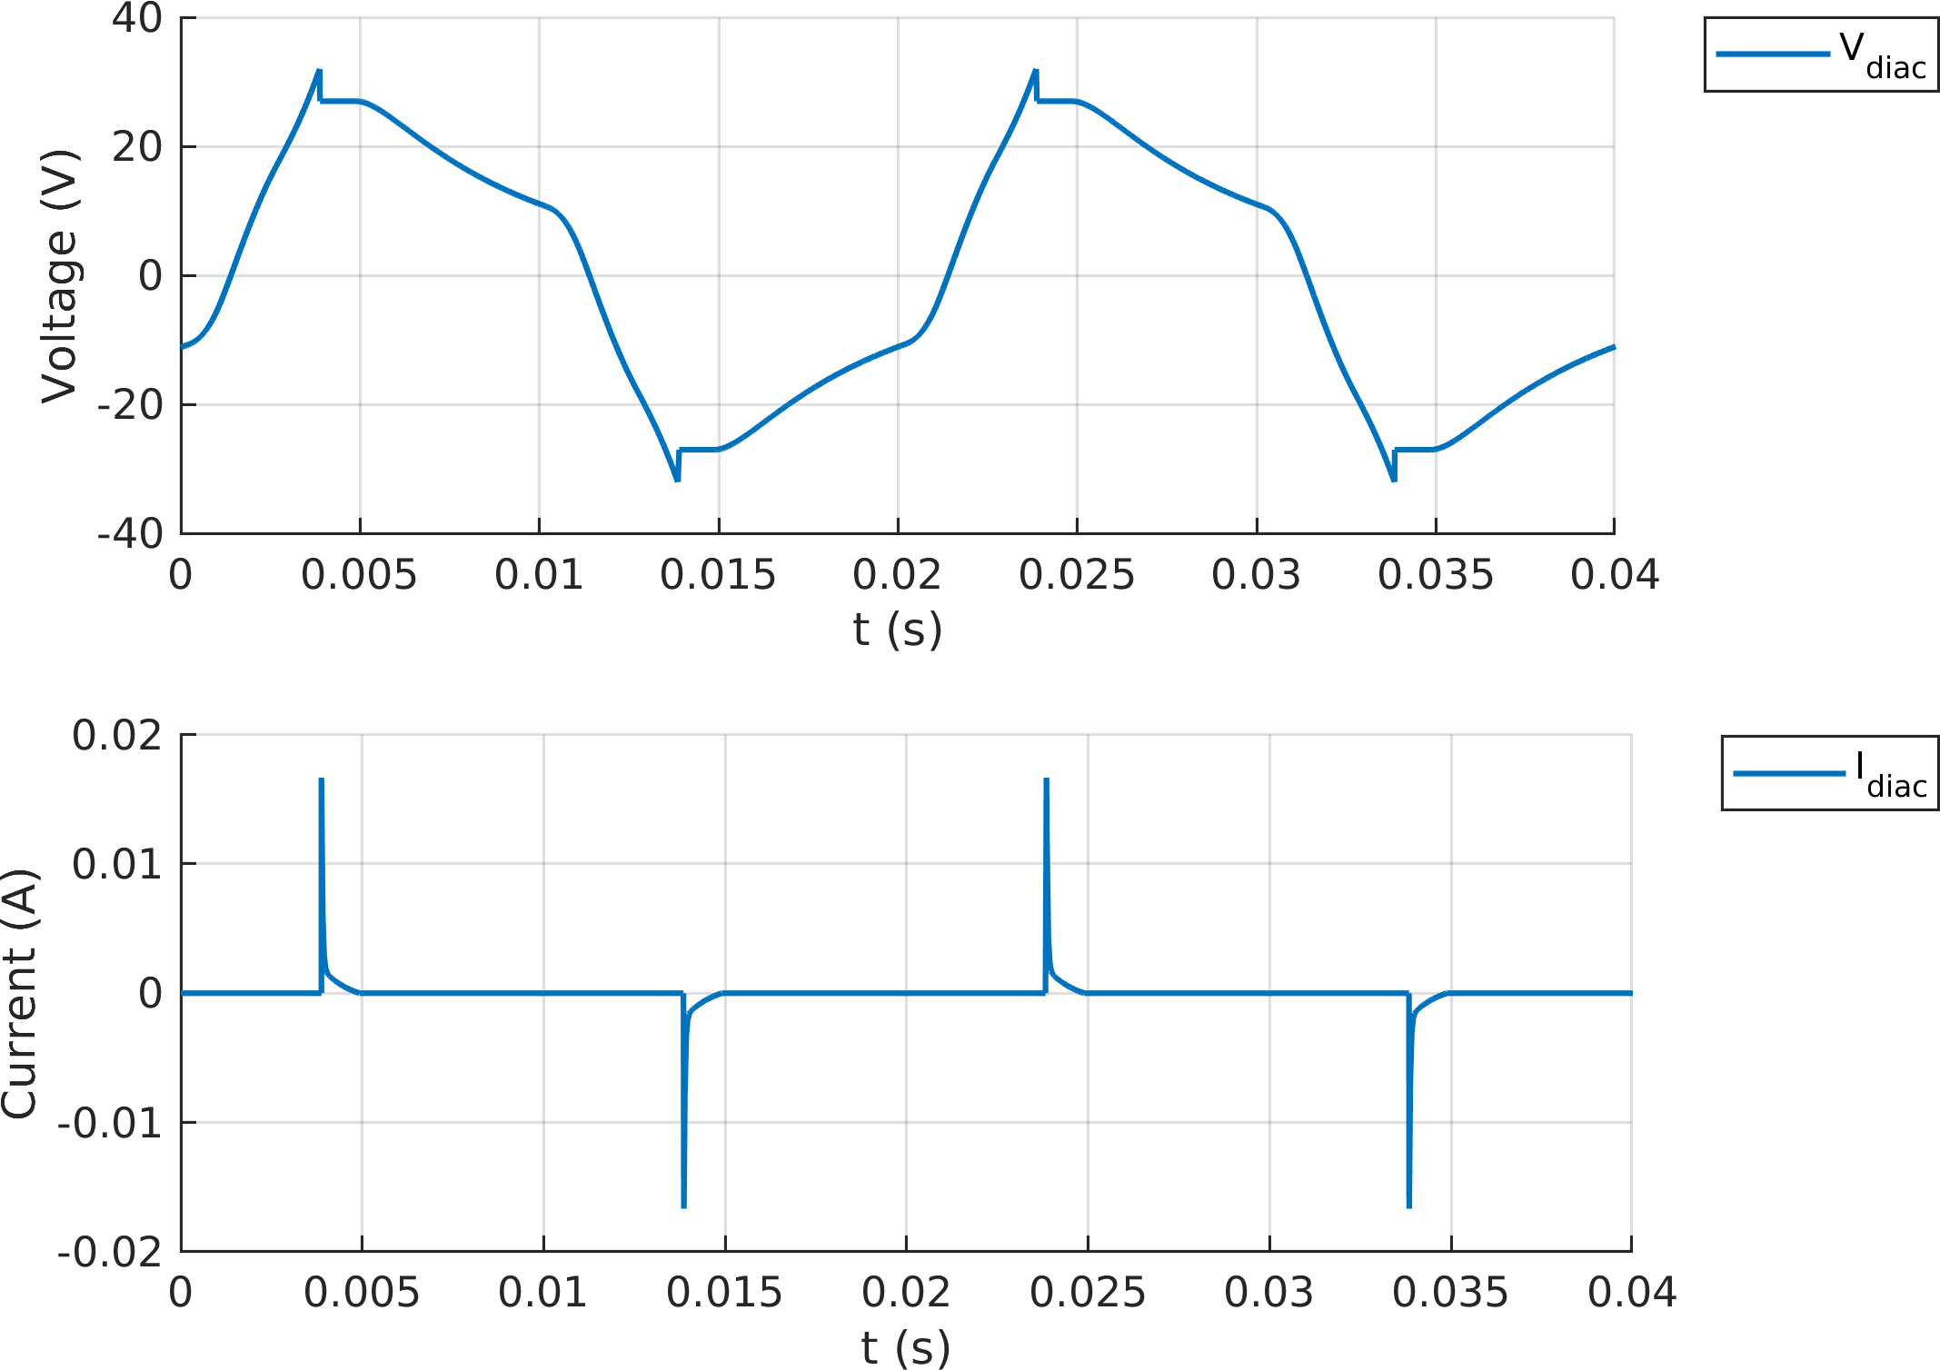

Figure 7: Triac-Diac Control Voltage & Current

In Figure 3, the diac control voltage and current are shown for the kettle load simulation. This is provided for comparison against oscillography recorded during testing.

Tables 3 and 4 show summary values of the input and output side voltages and currents from the simulations.

Table 3: Triac-Diac Simulation Summary (Input Side)

| Load | R2  (kΩ) | VIN (VRMS) | IIN (ARMS) | PIN  (W) | QIN  (var) | SIN  (VA) | PF | **IIN**  **THD (%)** |
| --- | --- | --- | --- | --- | --- | --- | --- | --- |
| Starting | 137 | 219.8 | 6.48 | 179.1 | 1414 | 1425 | 0.13 | 135.2 |
| No Load | 21 | 219.5 | 8.22 | 961.8 | 1526 | 1804 | 0.53 | 64.06 |
| Kettle Load | 17 | 218.8 | 17.95 | 2582 | 2958 | 3926 | 0.66 | 39.31 |

Table 4: Triac-Diac Simulation Summary (Output Side)

| Load | VOUT  (VAVG) | VOUT Ripple | IOUT (AAVG) | IOUT Ripple | POUT  (W) | **Efficiency (%)** |
| --- | --- | --- | --- | --- | --- | --- |
| Starting | 10.46 | 152.3 | 13.21 | 8.67 | 143 | 79.87 |
| No Load | 175.1 | 309 | 5.19 | 16.41 | 941 | 97.84 |
| Kettle Load | 175.1 | 307.4 | 13.77 | 30.61 | 2523 | 97.71 |

Additional key information about components was extracted from the simulations and is shown in Tables 5, 6, 7, and 8. The values from preliminary simulations presented in the previously submitted simulation report were used for component selection. The values shown here are from subsequent simulations utilizing updated model parameters based on the selected components and are verified against the selected component ratings to verify adequecy.

Table 5: Triac-Diac Simulation Key Diode Values

| Load | Iavg  (A) | IRMS  (A) | VMAX  (V) | PLoss (W) |
| --- | --- | --- | --- | --- |
| Starting | 6.6 | 7.5 | 151 | 7.8 |
| No Load | 2.6 | 5.8 | 305 | 3.2 |
| Kettle Load | 6.9 | 12.7 | 306 | 9.2 |

Table 6: Triac-Diac Simulation Key Triac Values

| Load | Iavg  (A) | IRMS  (A) | VMAX  (V) | PLoss (W) |
| --- | --- | --- | --- | --- |
| Starting | 2.8 | 6.5 | 311 | 4.3 |
| No Load | 5.2 | 8.2 | 138 | 7.8 |
| Kettle Load | 13.1 | 18.0 | 126 | 22.2 |

Table 7: Triac-Diac Simulation Key Capacitor Values

| Load | C1 IRMS  (mA) | C1 VMAX  (V) | C2 IRMS  (mA) | **C2** **VMAX**  **(V)** |
| --- | --- | --- | --- | --- |
| Starting | 0.9 | 41.3 | 0.9 | 32.0 |
| No Load | 1.6 | 60.2 | 1.0 | 32.0 |
| Kettle Load | 1.5 | 55.4 | 1.0 | 32.0 |

Table 8: Triac-Diac Simulation Key Resistor Value

| Load | R1 IRMS  (mA) | R1 P  (mW) | R2 IRMS  (mA) | R2 P  (mW) | **R3 IRMS**  **(mA)** | **R3 P**  **(mW)** |
| --- | --- | --- | --- | --- | --- | --- |
| Starting | 1.5 | 2.3 | 1.5 | 309 | 0.7 | 8 |
| No Load | 2.2 | 4.7 | 2.2 | 98 | 0.9 | 13 |
| Kettle Load | 2.0 | 4.1 | 2.0 | 69 | 0.8 | 10 |